Bowen AGM Sat 17th October 2020

Village Hotel Leeds South
Capitol Boulevard West Morley, Leeds, England, LS27 0TS
https://www.village-hotels.co.uk/

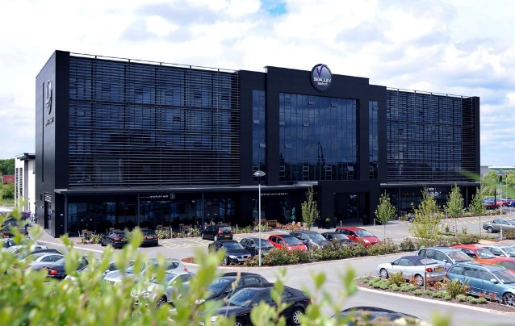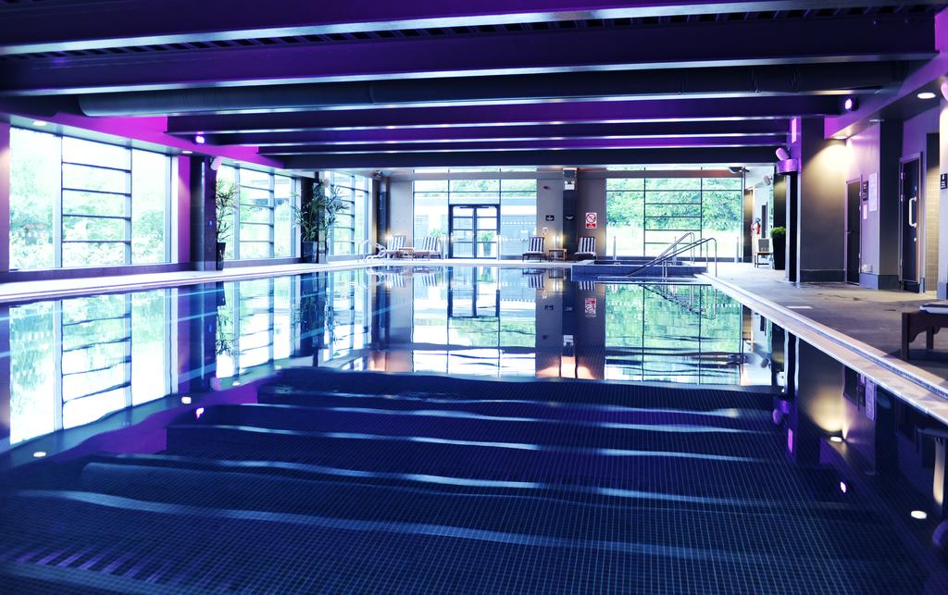
Village Hotel Leeds South- boasts a stunning 30 yards indoor pool, chic rooms with plasma-screen TVs and a choice of dining experiences are all offered at this contemporary and stylish 3-star hotel. The hotel is 15 minutes’ drive away from Leeds and is situated just off the M62 motorway. 2.1 miles from Morley Station

Accommodation Rates based on bed & breakfast ––cancellation policy 3 month prior.
Fri &Sun per night Single £60.00 -Double/Twin per room £70.00
Sat night single £80.00, Double/Twin £90.00 (limited availability)
Dinner- Fri night- 3 course £28.00.

Please confirm your attendance by filling in the box below and return with your full payment.
If you require accommodation then full payment needs to be paid by 28th Feb as after this date accommodation will be on request basis only and subject to rate availability.

Name & membership No
Address
Address
Contact no
Email address
Dinner Friday Night £28.00 | Attending YES/NO
Dietary Requirements
Accommodation Fri 16th October  Single £60.00- Twin/Double £70.00 | Type of room
Accommodation Sat 17th October  Single £80.00- Twin/Double £90.00 | Type of room
Accommodation Sun 18th October  Single £60.00 -Twin/Double £70.00 | Type of room

- Payment for the AGM only - £60.00 (and 8 CPD points awarded for full-day attendance)
- Payment for Accommodation/Dinner £_____________________

- Total Payment: for AGM, accommodation and/ or Dinner if attending: £______________

- Payment by CHQ payable to Bowen Association UK and post with your booking form to Veena Lidbetter, flat 10 Coronet House, 62-66 Uxbridge Rd, Stanmore, HA7 3LL
- BAC payment –to Bowen Association UK, HSBC Bank– Sort code 40 28 24 Account 81286447
(Remember to add your membership no and name as reference when making payment)

